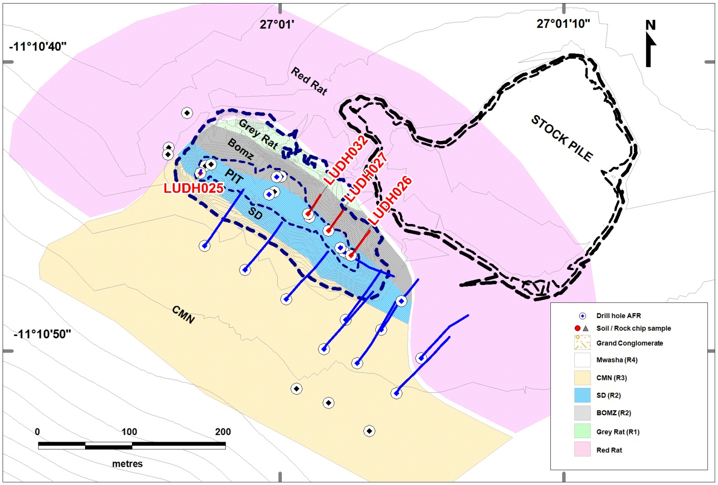
Figure 1: Luisha diamond drill holes (blue); 10 as holes cored from surface and 12 as diamond tails to RC pre-collars; holes with reported assay results are highlighted red (4).

