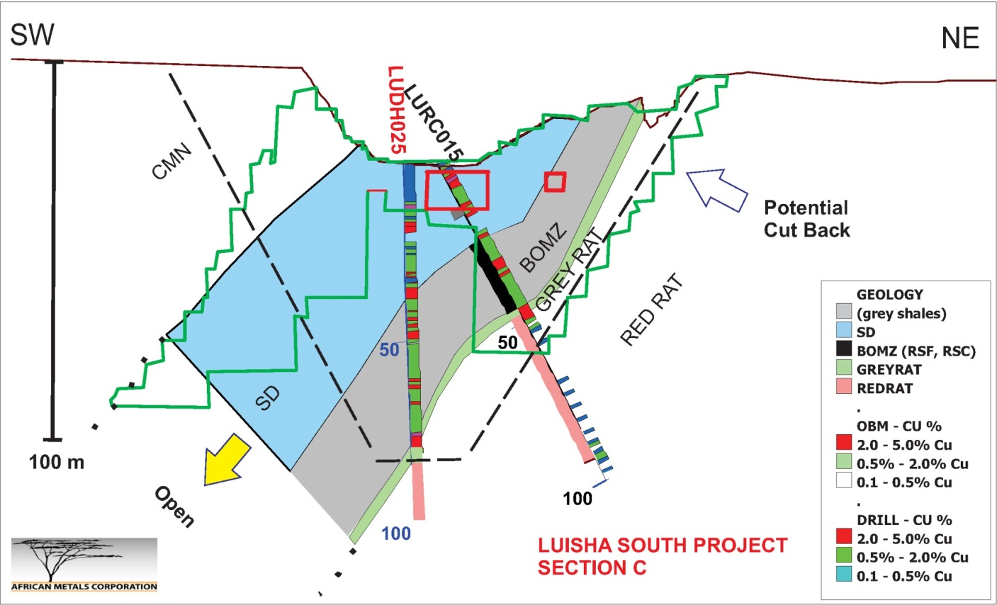
Figure 2: Luisha diamond drill hole LUDH025, successfully tested interpolation gap in the resource block model and confirmed down dip continuation of mineralization.

