Figure 1: Location of holes drilled on section 5650N at Kiaka Central Area
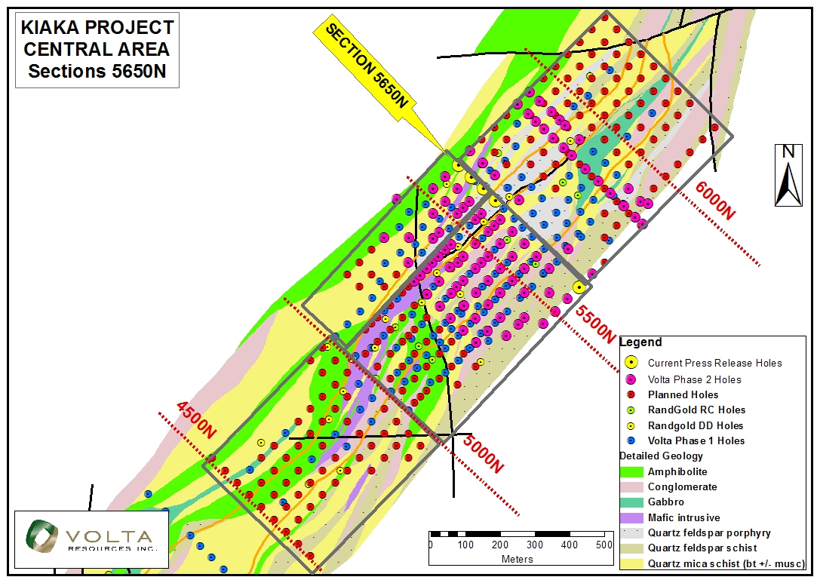

Figure 2 : Section 5650N


