Figure 2: LML49 regional exploration targets

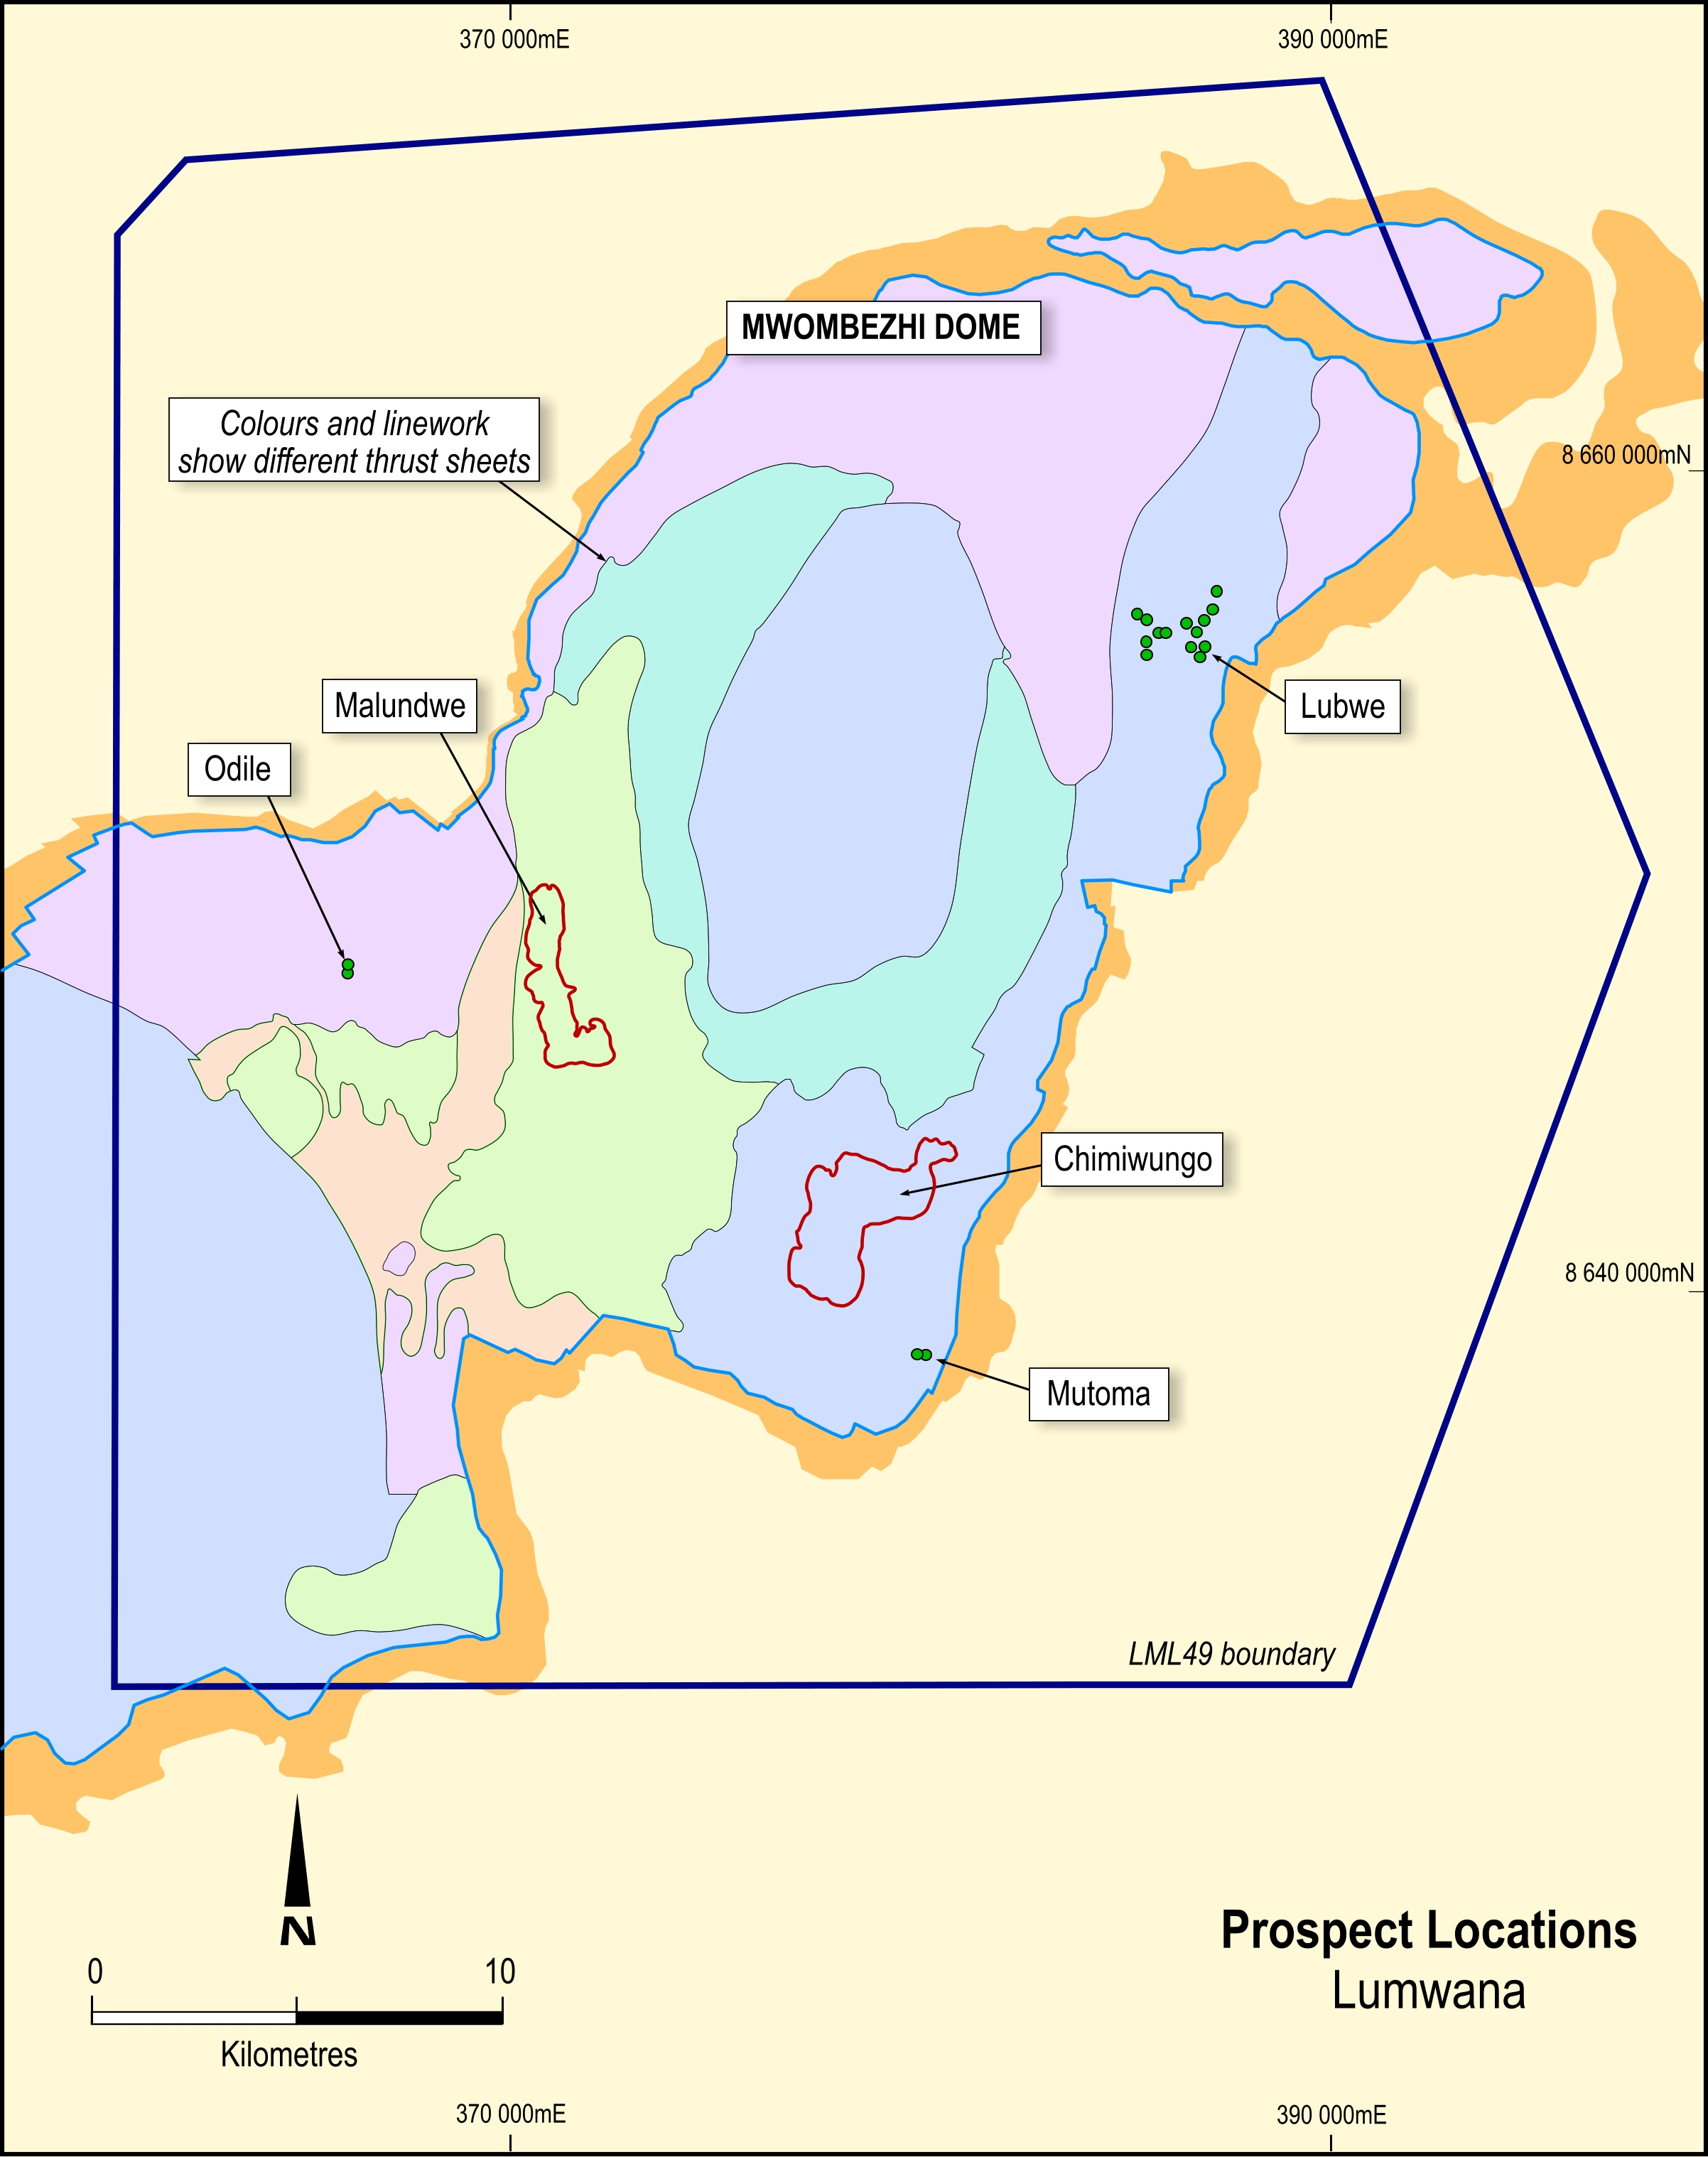
Source: Equinox Internal Data

