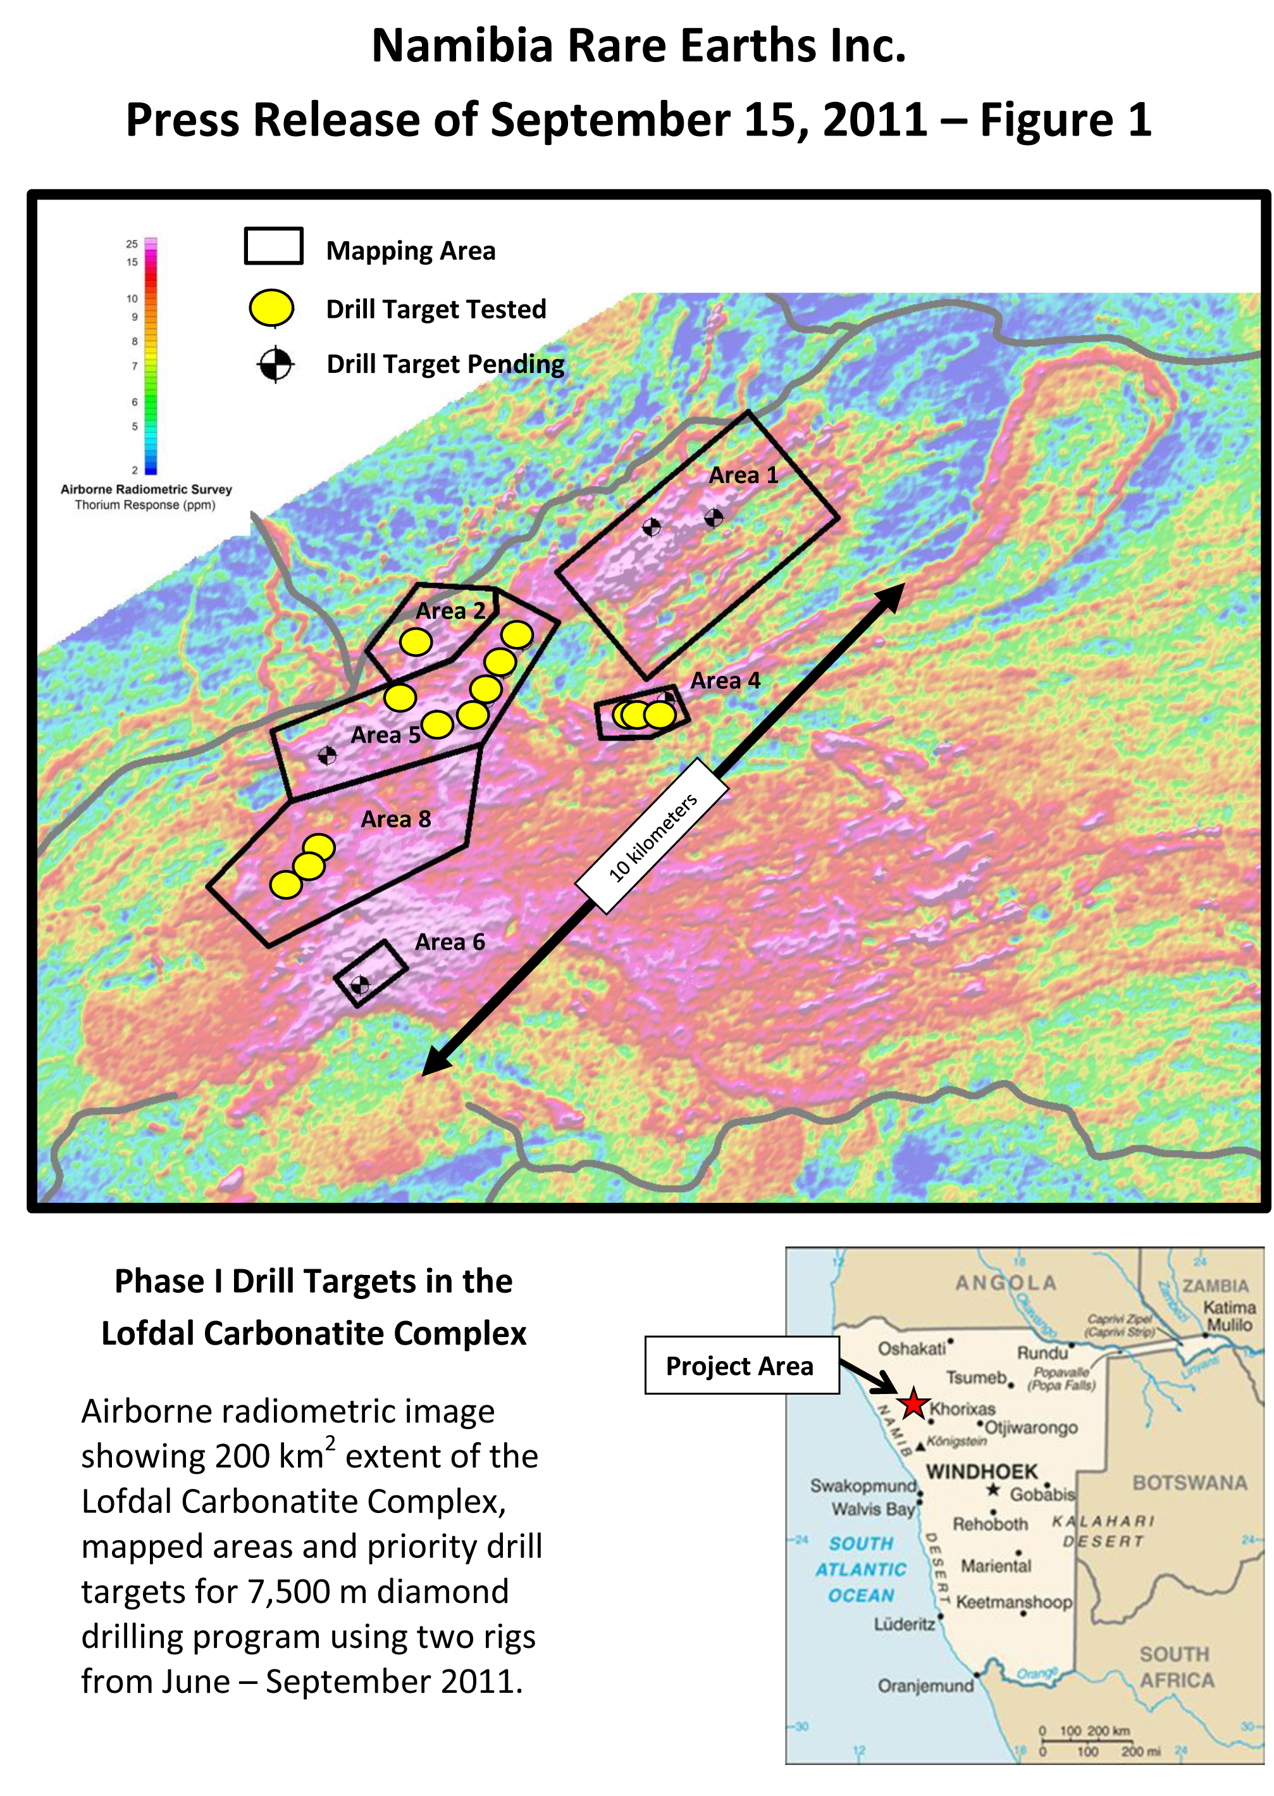
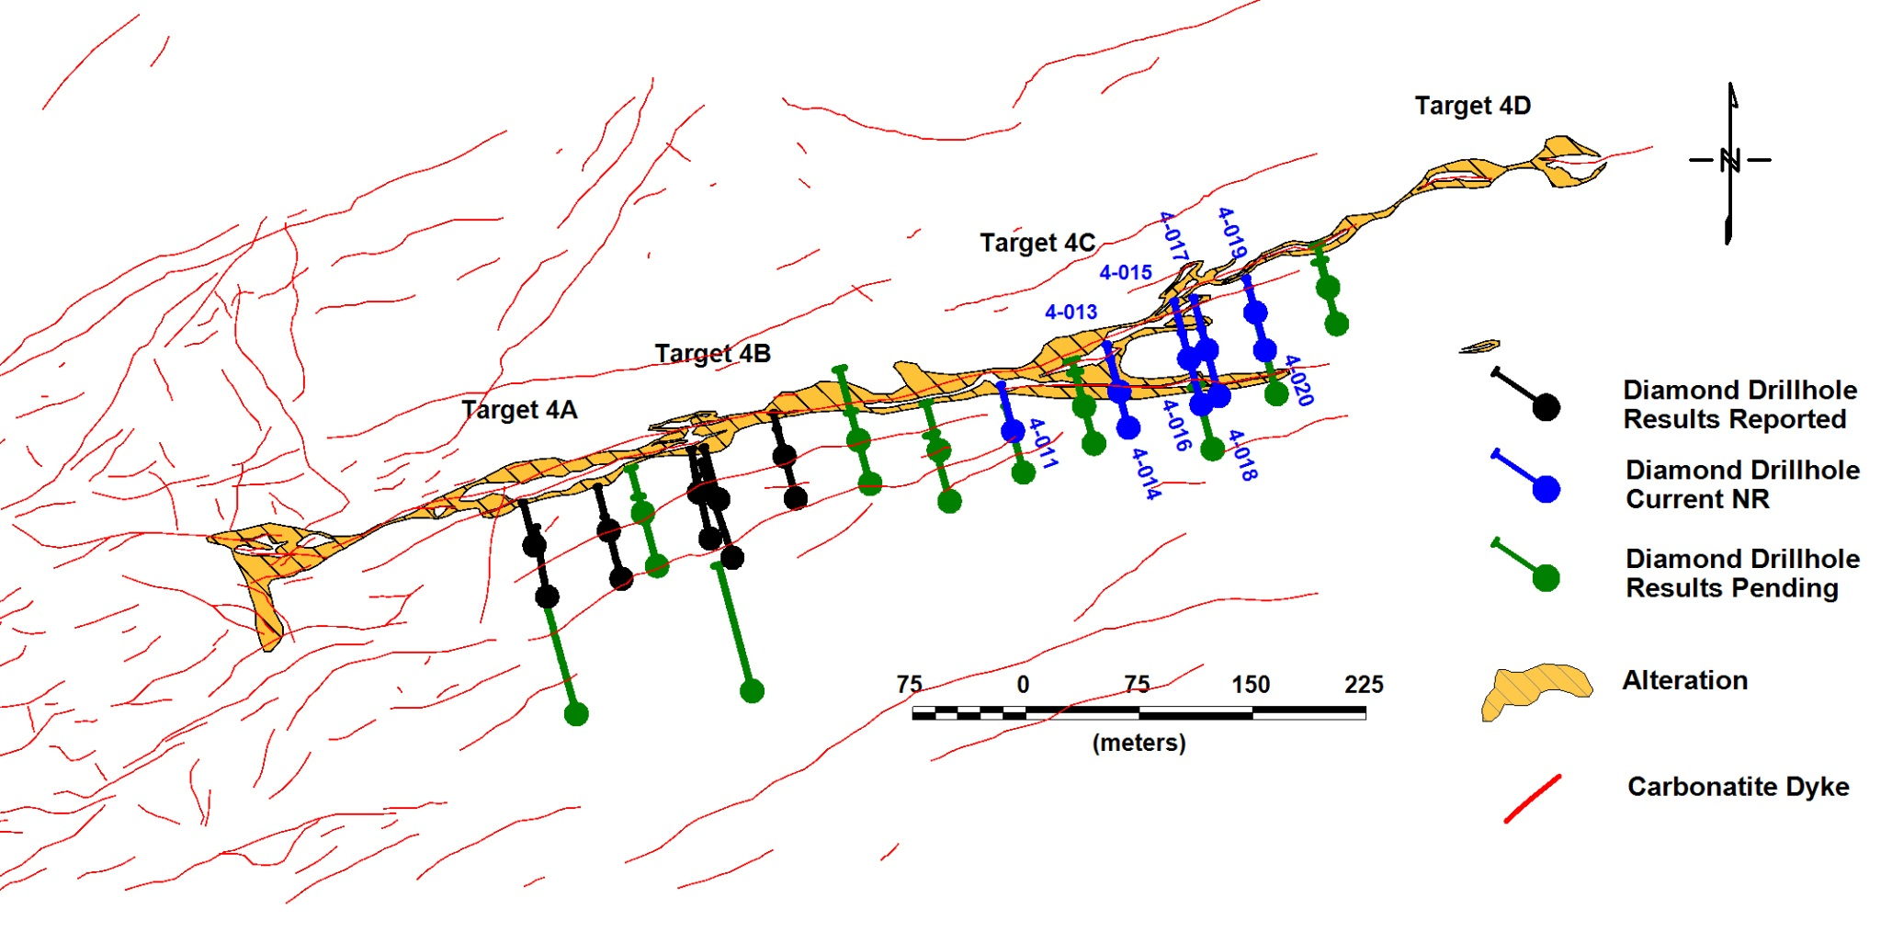
NAMIBIA RARE EARTHS INC.
Press Release of September 15, 2011 – Figure 2
Diamond Drill Plan and Progress in Area 4
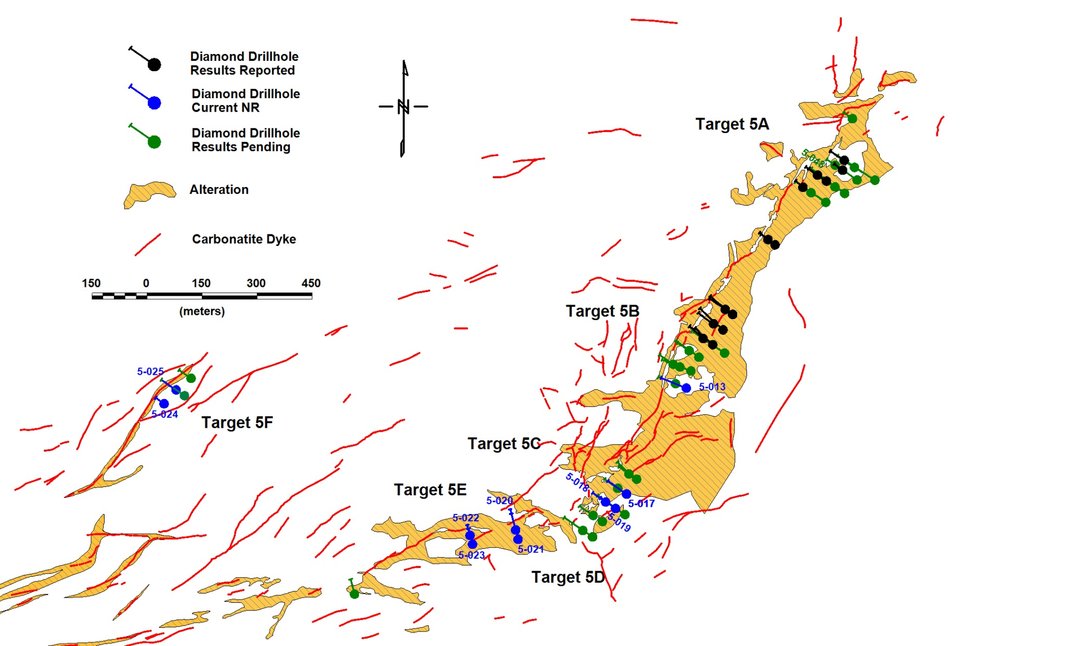
NAMIBIA RARE EARTHS INC.
Press Release of September 15, 2011 – Figure 3
Diamond Drill Plan and Progress in Area 5
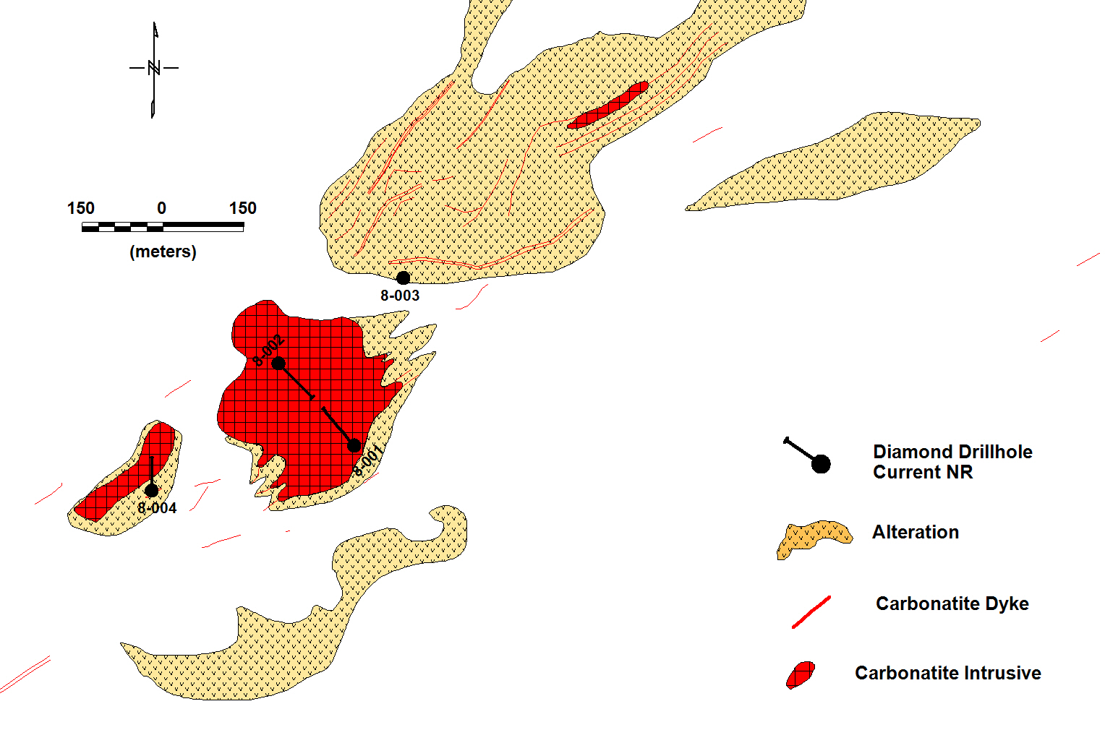
NAMIBIA RARE EARTHS INC.
Press Release of September 15, 2011 – Figure 4
Diamond Drill Plan and Progress in Area 8
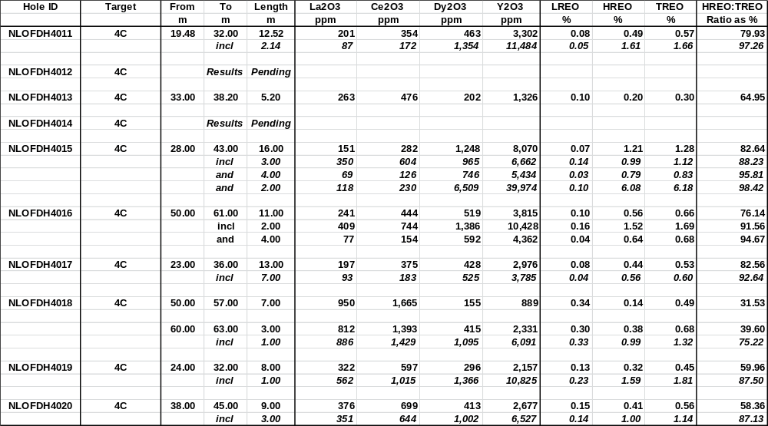
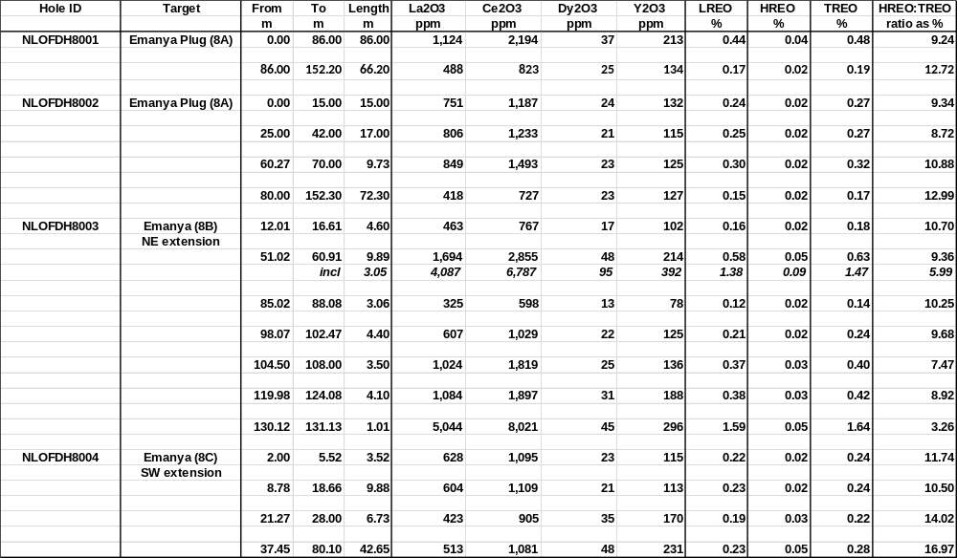
NAMIBIA RARE EARTHS INC.
Press Release of September 15, 2011 – Table 1
Summary of Significant Drill Intercepts in Area 4
Summary of Significant Drill Intercepts in Area 8

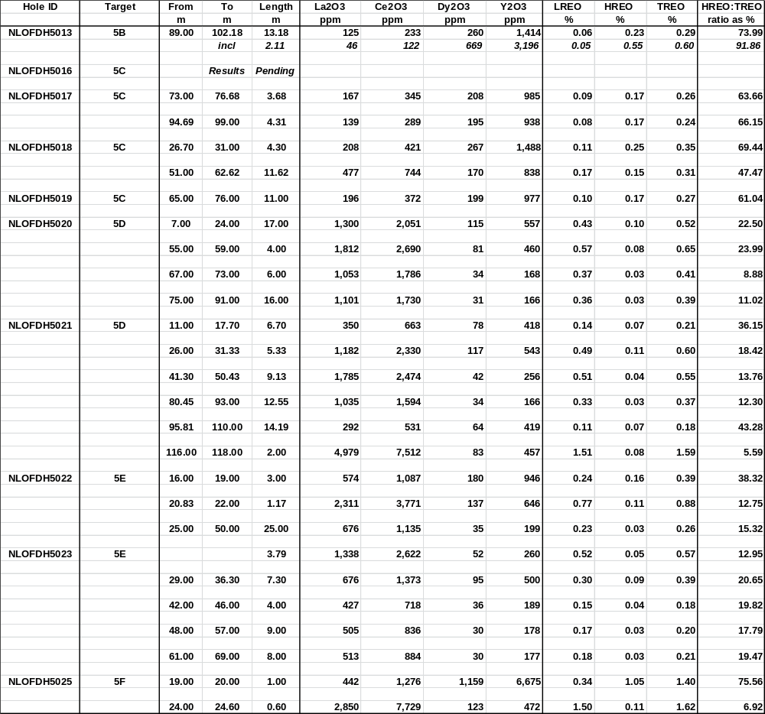
NAMIBIA RARE EARTHS INC.
Press Release of September 15, 2011 – Table 1 (continued)
Summary of Significant Drill Intercepts in Area 5

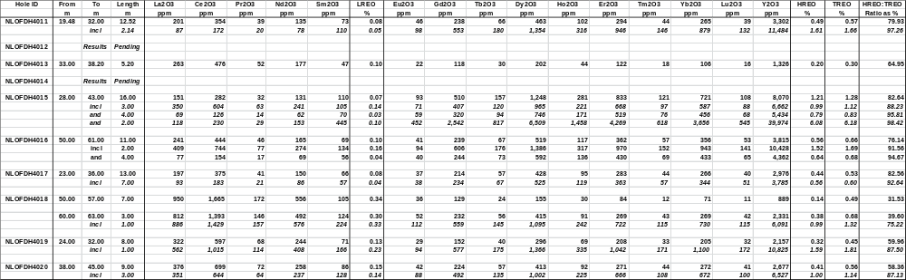
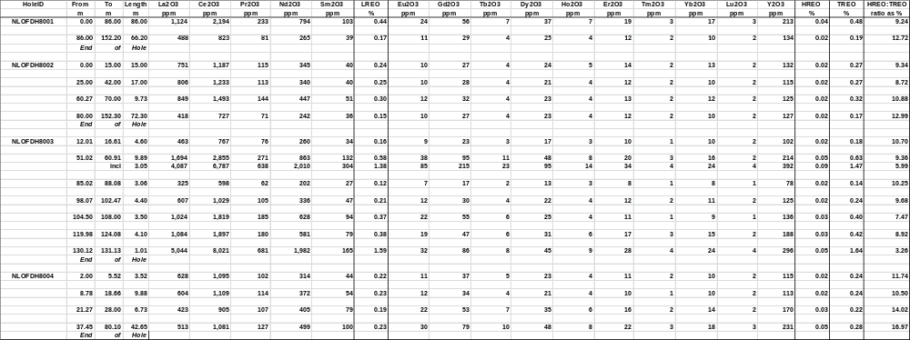
NAMIBIA RARE EARTHS INC.
Press Release of September 15, 2011 – Table 2
Complete Listing of All Analytical Results from Significant Drill Intercepts Area 4
Complete Listing of All Analytical Results from Significant Drill Intercepts Area 8

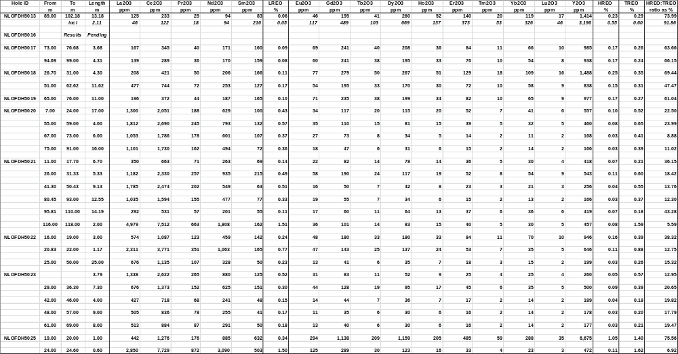
NAMIBIA RARE EARTHS INC.
Press Release of September 15, 2011 – Table 2 (continued)
Complete Listing of All Analytical Results from Significant Drill Intercepts Area 5
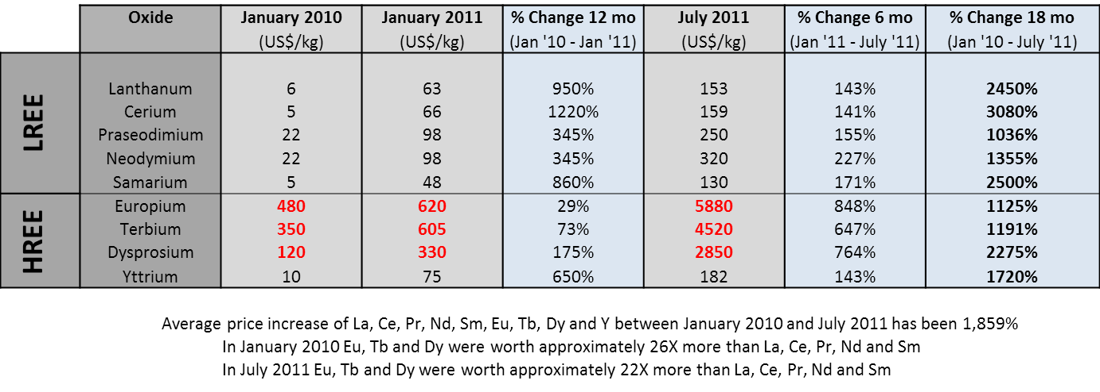
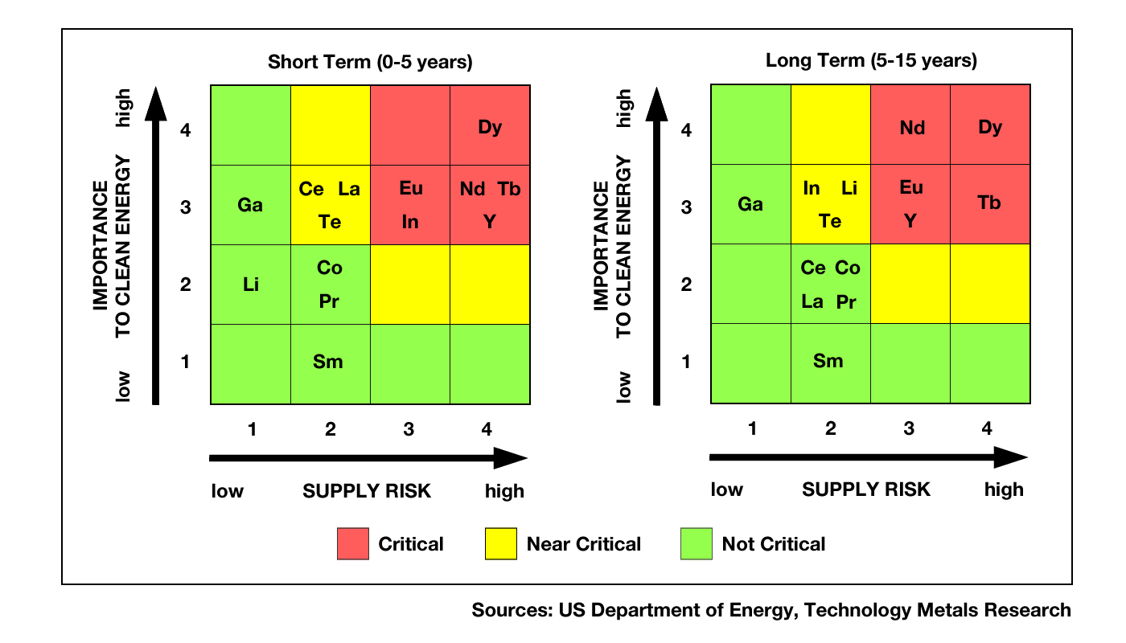
NAMIBIA RARE EARTHS INC.
Press Release of September 15, 2011 – Table 3
Increases in Selected Rare Earth Prices from January 2010 to July 2011
(Sources: Metal Pages, Asian Metals and Technology Metals Research)
NAMIBIA RARE EARTHS INC.
Press Release of September 15, 2011 – Figure 5
Criticality Index for Clean Technology Development Showing Forecast Supply Shortages of Most Important Metals


